RESOLUTION NO.__________

RE: CERTIFICATE OF APPROPRIATENESS UNDER THE
PROVISIONS OF THE ACT OF THE PENNSYLVANIA
LEGISLATURE 1961, JUNE 13, P.L. 282 (53
SECTION 8004) AND BETHLEHEM ORDINANCE NO.
3952 AS AMENDED.

WHEREAS, it is proposed to move the entry door to install an ADA ramp, decrease the size of the garage door and install new spouting at 321 W. Fourth Street

NOW, THEREFORE, BE IT RESOLVED by the Council of the City of Bethlehem that a Certificate of Appropriateness is hereby granted for the work.

Sponsored by: (s)

(s)

ADOPTED BY COUNCIL THIS DAY OF

(s)
President of Council

ATTEST:

(s)
City Clerk

HISTORIC CONSERVATION COMMISSION

CASE # 626– It is proposed to move the entry door to install an ADA ramp, decrease the size of the garage door and install new spouting at 321 W. Fourth Street
OWNER/APPLICANT: Episcopal Ministries of D.B., Inc/ Paul Thiessen, JPT Contracting

The Commission upon motion by Ms. Starbuck seconded by Mr. Traupman adopted the proposal that City Council issue a Certificate of Appropriateness for the proposed work described herein:
- The proposal to move the entry door to install an ADA ramp, decrease the size of the garage door and install new spouting at 321 W. Fourth Street was represented by Tina Sargent, Diane Elliott, and Russ Pacala, AIA.

  - The building will be altered as shown in the drawings submitted to the HCC with the following modifications and clarifications.

  - The new door in the new door opening will be a 4 panel smooth fiberglass door in a steel door jamb/frame.

  - The existing door opening will be infilled with vertically oriented boards or siding to match in material and color the infilled door opening on the second floor directly above.

  - The smaller garage door will be installed as proposed but with brick infill and not exposed CMU. The brick will be set back at least 1” to reference the original opening size, and painted to match. There will be wood paneled infill above the overhead door and no brick. The material for the infill will be wood or a composite wood-like material such as Azek.

  - The new overhead door material will be insulated metal slats.

  - New gutter and down spouts will be half-round and round respectively and painted to blend the exterior.
- The motion to approve the proposed work was unanimously approved.

CU: cu
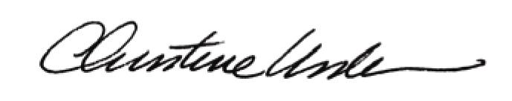

By:

Date of Meeting: September 18, 2017 Title: Historic Officer

